quantitative Module
Learning Curves

Discussion Questions
1. Limitations of the use of learning curves include:
- Any change in the process, product, or personnel, disrupts the curve
- Volume must increase for a learning curve to exist
- Not all products, processes, or management styles benefit from learning to a significant degree
2. Some applications of the learning curve are: Internal manpower forecasting, scheduling, establishing costs and budgets; external purchasing and subcontracting of items; and strategic evaluation of company and industry performance, including costs and pricing.
3. Three approaches to solving learning curve problems are by: logarithms, learning curve coefficients, and arithmetic.
4. We cannot determine the implications for Great Lakes Services, Inc., if the engine in the tug boats is changed. Any change in product or process may disrupt the curve and require recalculations.
5. Learning curves are not as applicable to assembly lines for the short run as in other activities because the whole line is paced to run/produce at a certain speed/output. Many lines mix technology, which is fixed-speed, with humans.
6. The learning curve can be disrupted by any change in process, product, or personnel.
7. The doubling effect in learning curves means that each time output is doubled (say from 4 to 8 units), the time required to produce the doubled unit is x% of the time to produce the base unit, where x stands for the learning curve rate. So if the 4th unit took 10 hours and the learning curve rate is 85%, the 8th unit will take (0.85) (10 hours) = 8.5 hours.
8. Pursue a steeper learning curve by:
- Following an aggressive pricing policy
- Focusing on continuing cost reduction and productivity improvement
- Building on shared experience
- Keeping capacity growing ahead of demand
Active Model Exercise
ACTIVE MODEL E.1: Unit Curve, Cumulative Curve
and Costs
1. If the learning is not as good as expected and rises to 90%, how much will the 4th boat cost?
$4,050,000
2. What should the learning curve rate be to keep the total cost of the first 4 boats below $16,000,000?
0.81
3. How many boats need to be produced before the cost of the next boat is at or below $4,000,000?
3
4. How many boats need to be produced before the average cost of each boat is below $4,000,000?
6
End-of-Module Problems
E.1 1st return takes 45 minutes
(a) 2nd return takes (45 min)(0.85) = 38.25 min
(b) 4th takes (38.25)(0.85) = 32.5 min
(c) 8th takes (32.5)(0.85) = 27.6 min
E.2 1st day took 9 hours and 23 min = 563 min
(a) 2nd day = (563)(0.90) = 507 min (with rounding)
(b) 4th day = (507)(0.90) = 456 min
(c) 8th day = (456)(0.90) = 410 min
(d) 16th day = (410)(0.90) = 369 min
E.3 (a) For the 25th unit, at an 80% learning factor, the learning-curve coefficient (from Table E.3) is 0.355
15 × 0.355 = 5.325 minutes
(b) For the first 10 units, at an 80% learning factor, the learning-curve coefficient (from Table E.3) is 6.315
15 × 6.315 = 94.725 minutes
E.4 Cumulative times using Table E.3:
(a) First 3 = (2.746)(563) = 1,546
(b) First 6 = (5.101)(563) = 2,872
(c) First 8 = (6.574)(563) = 3,701
(d) First 16 = (12.040)(563) = 6,779
E.5 T1 = 30 hr 80% learning curve
(a) T5 = (30)(0.596) = 17.88 hr
(b) 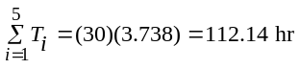
(c) T18 = (30)(0.394) = 11.82 hr
(d) 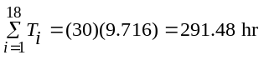
E.6 $5,000 = cost/hr
(a) T10 = T1(0.477) = 30(0.477) = 14.31 hr
(b) Cost10 = (14.31 hr)($5,000/hr) = $71,550
(c) 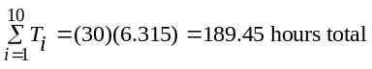
Cost for all 10 = (189.45)($5,000/hr) = $947,250
E.7 T1 = 112; Rate = 90%
The cumulative factor for the 8th unit at 90%, Table E.3 is 6.574. So the first 8 units will take 6.574(112) = 736.29. The last 7 units will take 736.29 – 112 = 624.29 hours.
E.8 T1 = 5 hr T2 = 4 hr
(a) Learning rate = 4/5 = 80%
(b) T3 = T1 × C = (5)(0.702) = 3.51
(c) T4 = 5(0.640) = 3.2
T5 = 5(0.596) = 2.98
T6 = 5(0.562) = 2.81
(d) 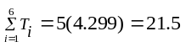
E.9 For the 15th unit at a 90% learning factor, the learning-curve coefficient (from Table E.3) is 0.663.
6 × 0.663 = 3.978 hours
E.10 T1 = 80 hours
T4 = ?
Use the doubling effect twice to reach the 4th unit
(a) 95% L.C.
(0.95)(0.95)(80 hours) = 72.2 hours
(b) 87% L.C.
(0.87)(0.87)(80 hours) = 60.552 hours
(c) 72% L.C.
(0.72)(0.72)(80 hours) = 41.472 hours
E.11 (a) T4 = T1(0.92)(0.92) = 46 × 0.92 × 0.92 = 38.9 hours
T8 = T4(0.92) = 35.8 hours
(b) T4 = T1(0.84)(0.84) = 46 × 0.84 × 0.84 = 32.4 hours
T8 = T4(0.84) = 27.3 hours
(c) T4 = T1(0.77)(0.77) = 46 × 0.77 × 0.77 = 27.3 hours
T8 = T4(0.77) = 21.0 hours
E.12 (a) For Torri: 4th unit required 5 hours; 8th unit required
4 hours
When volume doubled from 4 to 8, learning improved 1 hour or 20% (1 hr/5 hr = 0.2) or a learning curve of 80%.
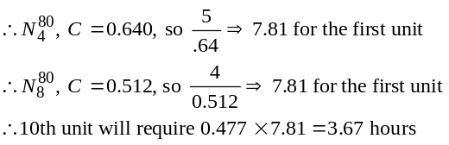
So Torri will not make the standard; 10th unit is estimated to take 3.67 hours.
(b) For Julie: 3rd unit required 4 hours; 6th unit required
3 hours
When volume doubled from 3 to 6, learning improved 1 hour or 25% (1 hr/4 hr = 0.25) or a learning curve of 75%
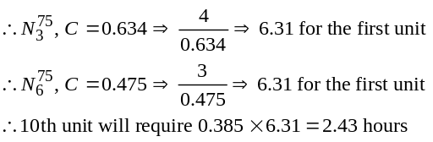
Neither is expected to reach 1 hour by the 10th unit.
E.13 Using Table E.3, 6th unit at 80% = 0.562
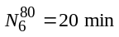
Thus,
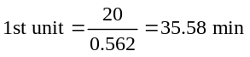
Using Table E.3, 3rd unit at 80% = 0.702.
Therefore the 3rd unit should require (35.58 × 0.702) =
24.98 min, or about 25 minutes.
E.14 T3 = 20,000, Cost = $40/hour, 85% learning curve,
Resolve for plane #1 N = 3, C = 0.773 for 85%
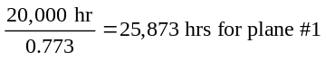
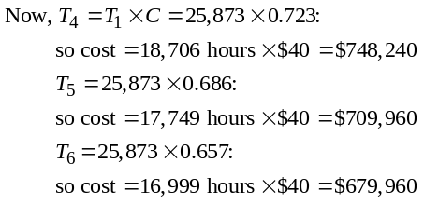
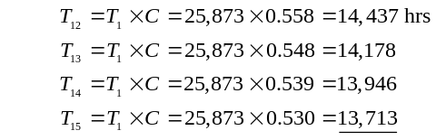
E.15
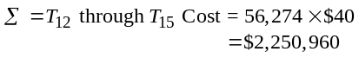
E.16 (a) Expected price at a volume of 1.4 × 1012 bits:
- From Table E.3:
Learning curve coefficient for 0.70 learning curve factor and doubling:
C = 0.7000
Cost:
Cost = Base cost × Learning curve coefficient
= 100 × 0.7000 = 70 milli-cents/bit
(b) Expected price at a volume of 89.6 × 1012 bits
- Using the general learning curve formula: Cost of the nth unit = TN × Ln where: T is the present unit cost, L is the learning curve factor, n is the number of times the volume will double over the present volume.
- For the present problem:
T = 100 milli-cents/bit
L = 0.7
n = 7 (Note: 89.6/0.7 = 128 = 27)
Therefore, cost per bit for a volume of 89.6 × 1012 is given by:
Cost = 100 × 0.77 = 100 × 0.0823543 = 8.235 milli-cents/bit
E.17 T3 = 460; cost = $60/hour; 80% learning curve. Factor for 3rd unit, Table E.3 = 0.702
Estimated time for turbine number 1 = 460/.702 = 655.27
Using factors from Table E.3
T4 = 655.27(0.64) = 419.37 hours = $25,162.
T5 = 655.27(0.596) = 390.54 hours = $23,432.
T6 = 655.27(0.562) = 368.26 hours = $22,096.
E.18 Time to produce eighth locomotive = 28,718 hours
Learning factor = 0.80
- Time to produce first engine:
- From Table E.3: Learning curve coefficient for 0.80 learning curve factor and 8th unit:
C = 0.5120
- Time (first engine) is given by:
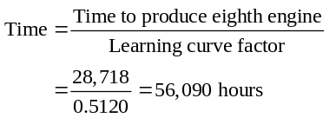
- Time to produce the tenth engine:
- Learning curve coefficient for 0.80 learning curve factor and 10th unit:
C = 0.4765
- Time (tenth engine) is then given by:
Time = First engine time × C = 56,090 × 0.4765
= 26,755 hours
Note rounding in Table E.3 to 0.477 for the value of C.
E.19 (a) From Table E.3, the 40 units will require 700 × 13.723 =
9,606.1 hours.
(b) The average time per unit is 9,606.1/40 = 240.2 hours.
(c) It will take 9,606.1/2,080 = 4.62 workers to complete the contract within one year.
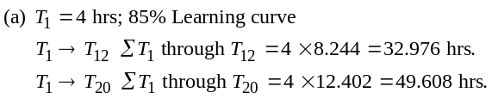

E.20
(b) If 5th took 2.5 hr,
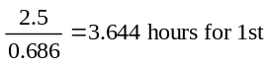
This implies T1 → T12 = 3.644 × 8.244 = 30.04 hr
The quote is high. The learning curve rate may have been better for the previous crew.
E.21 (a) 4.0 is 90% of 4.44 hours
(b) 4.44 × 0.729 = 3.24 hours
(c) 4.44 × 6.574 = 29.2 hours
E.22 (a) The firm can offer 25,000 hours of labor (10 employees
at 2,500 hours each). From Table E.3, five boats would
require 6000 × 4.339 = 26,034 hours, while four boats would require 6000 × 3.556 = 21,336 hours. Thus four boats can be completed, but five cannot.
(b) At the improved learning rate, five boats require 6000 × 4.031 = 24,186, now within the stated labor limits.
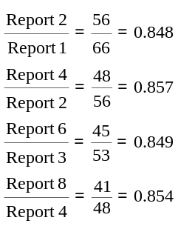E.23 (a) In order to estimate the learning curve rate, we take the ratios of the units that have doubled:

The learning curve rates are not identical for each paired comparison, but since they are in the range of 85 percent to 86 percent (average = .854), we can safely use 85 percent.
(b) Since the 6th report took 45 minutes, the 12th unit should take 85 percent of 45 minutes, or 38.25 minutes. Multiplying again by 85 percent yields a time of 32.5 minutes for the 24th report. One more multiplication yields a time of 27.6 minutes for the 48th report. An even more exact answer can be found using Excel OM or POM for Windows software. Or a third approach is the formula T_{N} = T₁C, where C ≈ 0.402 (from Table E.3):
T₄₈ = (66)(0.402) = 26.5 minutes
E.24 Time for first unit: 1 hour
Learning factor: 80%
- Find time for unit 100:
T₁₀₀ = T₁ × C_{10th unit} × C_{10th unit}
where C_{10th unit} is obtained from Table E.3:
- From Table E.3: Learning curve coefficient for 0.80 learning curve factor and 10th unit
C = 0.477
- Time (100th unit) is given by:
Time = 1 × C × C = 1 × 0.477 × 0.477 = 0.227 hours
E.25 (a) Management seems to be having considerable difficulty controlling costs. Actual cost is consistently above forecast or optimum; sometimes by as much as 30 percent–40 percent. In addition, costs for units 180–400 are seen to rise drastically—exceeding forecast by as much as 250 percent.
(b) Possible causes of excess cost include: fluctuations in the quality of raw materials, turnover in the workforce, inconsistent maintenance of machinery, and changes in the design of the product or production process. (If the product or process was changed, the company should have abandoned the existing learning curve.) It is not at all clear, however, that the raw material, workforce, or maintenance problems as individuals or in combination, are sufficient to explain the consistent and significant increase in cost over the last 200 units produced.
(c) The optimum time for the 10th unit is approximately 110 hours.
(d) The actual time for the 10th unit is approximately
135 hours.
Additional Homework Problems
Here are solutions to additional homework problems that appear at www.myomlab.com.
E.26 1st transplant took 563 minutes
Using Table E.3 and 90% rate
(a) 3rd transplant = (0.846)(563) = 476.3
(b) 6th transplant = (0.762)(563) = 429
(c) 8th transplant = (0.729)(563) = 410.4
(d) 16th transplant = (0.656)(563) = 369.3
E.27 4th = 18 min.
2nd = 20 min.
Then learning rate to this doubling is 90% (18/20 = .9 or 90%)
(a) Thus, the 1st job, x, took 0.9x = 20 min or x = 20/0.9 = 22.22 min.
(b) 3rd job T3 = T1 × C = (22.22)(0.846) = 18.8 min.
(c) 8th job T8 = T1 × C = (22.22)(0.729) = 16.2 min.
(d) Learning rate is 90%.
E.28 T1 = 300 days Rate = 85%
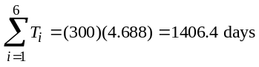
So the time for landfills 2 through 6 is 1406.4 – 300 = 1106.4 days
E.29 The first exam took 20 minutes; all 10 exams are projected to take 120 minutes; implying a learning curve coefficient of 6.
From Table E.3, this would imply a learning factor of
approximately 77%.
E.30 Time to produce first engine = 80,000 hours
Learning factor = 0.90
- From Table E.3:
Learning curve coefficient for 0.90 learning curve factor and 8th unit:
C = 0.7290
Time to produce eighth engine = 80,000 × C
= 80,000 × 0.7290
= 58,320 hours
E.31 Time for first unit: 1 hour
Learning factor: 80%
- Find time for unit 100:
T100 = T1 × C10th unit × C10th unit
where C10th unit is obtained from Table E.3:
- From Table E.3: Learning curve coefficient for 0.80
learning curve factor and 10th unit:
C = 0.477
- Time (100th unit) is given by:
Time = 1 × C × C = 1 × 0.477 × 0.477 = 0.227 hours

E.32 Step 1: Calculate the log10 of the quantities and the times as shown below.
Number | Time | Log(num) | Log(time)
1 | 4.80 | 0.00 | 0.68
2 | 4.50 | 0.30 | 0.65
3 | 4.43 | 0.48 | 0.65
4 | 4.05 | 0.60 | 0.61
5 | 3.91 | 0.70 | 0.59
10 | 3.72 | 1.00 | 0.57
15 | 3.31 | 1.18 | 0.52
20 | 3.37 | 1.30 | 0.53
25 | 3.07 | 1.40 | 0.49
30 | 2.98 | 1.48 | 0.47
35 | 2.71 | 1.54 | 0.43
40 | 2.65 | 1.60 | 0.42
50 | 2.56 | 1.70 | 0.41
100 | 2.28 | 2.00 | 0.36
150 | 2.53 | 2.18 | 0.40
200 | 2.43 | 2.30 | 0.39
Step 2: Plot the time taken as a function of the number packed and find the “trend,” as shown below:
Step 3: Calculate the slope of this line: Rise: –0.31; Run: 2;
Slope ≅ −0.155
Step 4: Multiply the slope by a scale factor to adjust for the physical size of the vertical and horizontal scales. For the graph shown, the scale factor is approximately 17.5/48, giving:
slope = −0.155 × 17.5/48 = −0.0565.
Time as Function of Quantity Produced
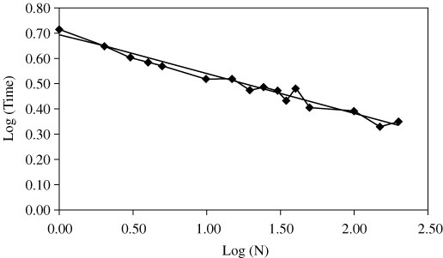
Step 5: Calculate the learning rate: Learning rate = 10–0.565 ≅
0.877 or 88%.

Case Study
SMT’S NEGOTIATION WITH IBM
This case is adapted from the book by Raymond Corey, Procurement Management: Strategy, Organization, and Decision Making, CMI Publishing Company, Inc., Boston. There is some additional background provided in that book. The case shows actual use of learning curves as applied to this purchase from SMT by IBM.
1(a). What are the advantages and disadvantages to IBM of this approach?
The advantage to IBM is that they have a reliable supplier that has been appropriately evaluated and should be able to perform in accordance with the contract. The disadvantage is that IBM may be paying slightly more than they might have been able to purchase the parts for on an ad hoc basis.
1(b). What are the advantages and disadvantages to SMT from this approach?
The advantage to SMT is that SMT has the business and knows what it will be paid. The disadvantage is that it may not make as much money on this contract, and that IBM knows its business and its costs. If SMT has indeed underestimated its costs by a significant amount, IBM’s knowledge of its business and its honesty in sharing information may prove to be beneficial.
2. How does the SMT proposed learning rate compare with that of other industries?
Refer to Table E.1. SMT is to produce a new machine to be used in the manufacture of logic chips. This machine is a highly advanced design, and contains a network of piping of different materials, both plastic and metal. The aircraft assembly industry is probably as close as any to the SMT example in terms of the nature of the actual assembly, the need for precision and very high quality control standards, the frequency of engineering change orders, etc. Historically, aircraft assembly has enjoyed a learning curve of about 80 percent. (See text for other comparisons).
This case may provide a good demonstration of not only how one uses learning curves in a practical situation, but also, as to how a supplier and purchaser can deal honestly with each other to develop a long-term relationship.
3. What are the limitations of the learning curve in this case?
The limitations of learning curves include any change in the specification, process, or personnel. Changes in any of these are likely to adversely affect the curve and have negative consequences on time and cost. Additionally, in this case both IBM and SMT are assuming that SMT can move from a 90% curve to an 85%
curve—an unproven assumption.
Learning curves for estimating, as may be true in this case, are often time-based because dollars add another variable. As suggested in the case, overtime pay may be an issue. If overtime becomes an issue then costs could escalate even if the 85% learning curve is achieved.

